Card Simulator

With a line of text you can generate a virtual deck of cards that you can click to flip and click and drag to move. Useful to anyone creating a card game.

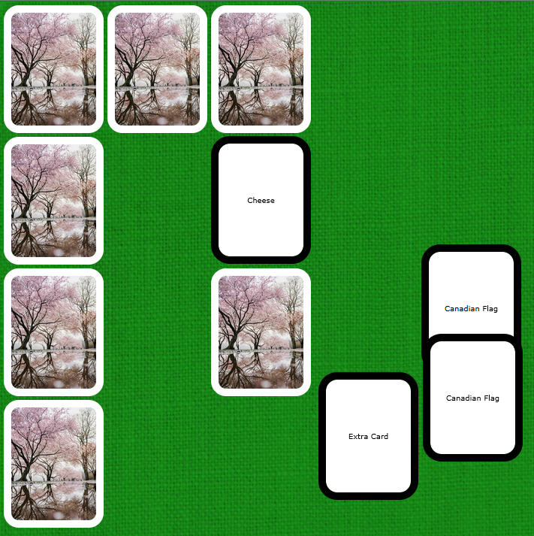
Has the additional feature of changing the card back with the time of year.

How to Use

Click the cheeseburger in the top right-hand corner to open the menu.

The controls are as follows:

1. This is where you enter the text. To follow along with this, you can copy and paste the example text into this.

Example Text:
Simple Memory Game
|Monkey:2
|Keys:2
|Cheese:2
|Bagel[NL]With Cream Cheese:2
|Canadian Flag:2
|Extra Card[FLIP]
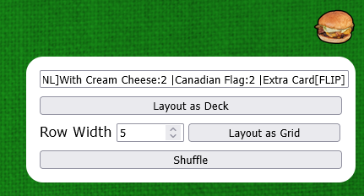
The program effectively ignores newlines/”enters”. You can add them for readability.
2. Generates the cards based on the text and lays them out in an overlapping horizontal line. This and “Layout as Grid” shuffles automatically on generating.

3. Generates the cards based on the text and lays them out in a in a grid/rectangle formation (ideal for a memory game). The “Row Width” field determines how many cards wide to make the rectangle.

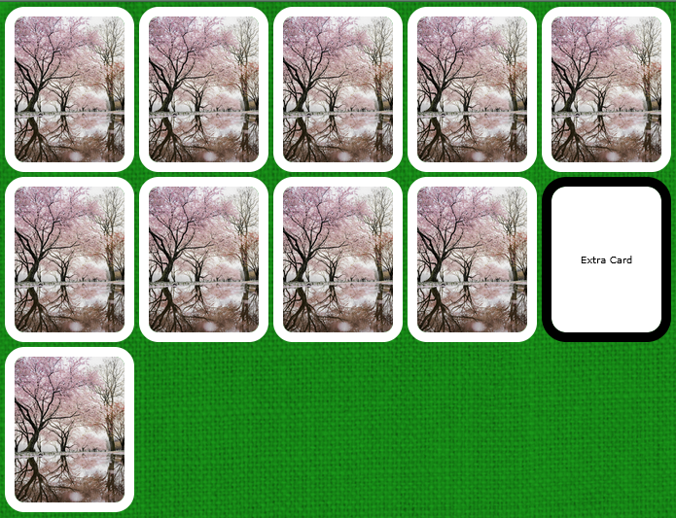

4. Randomizes the vertical arrangement of all cards effectively shuffling cards that are overlapping.
 | → | 

Syntax

Use this example demonstrating the full functionality of this application to write your own decks. You can write yours as one line or add newlines/”enters” for readability.
Simple Memory Game
|Monkey:2
|Keys:2
|Cheese:2
|Bagel[NL]With Cream Cheese:2
|Canadian Flag:2
|Extra Card[FLIP]

|
Separates the different kinds of cards. The first “card type” does not generate a card but rather changes the tab name (in this case: “Simple Memory Game”)

Text
The word(s) that show when the card is flipped.

[NL]
A newline/”enter” to break up the text.

[FLIP]
Cards are face-down by default. This starts the card off face up on creation.

:Number
The number of each kind of card to add to the deck. Must be This may be omitted when you only want one card.

Created by David Schriver
Last revision: 2025-03-27

